Form 7: No Objection Certificate

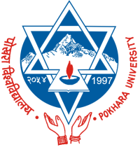 |  | Pokhara University  Council for Doctoral Studies  Pokhara-30, Kaski, Nepal
 |  | Format for No Objection Certificate from Current Employer (MPhil/ PhD in Management)

(Following format is to be printed on the letter head of the Organization where the candidate is currently employed)

NO OBJECTION CERTIFICATE

This is to certify that Mr. /Mrs./ Ms. ………………………………………………………………………………………………………… is employed with our organization as …………………………………………………………… since ………………………………… till date. He / She has an experience of ……………………………. years in our organization. We allow/relieve him/her to join PhD/MPhil programme at Faculty of Management Studies, Pokhara University in session 2080 for pursuing the study. It is further certified that he/she will be allowed to use facilities for research work at our organization.

Official Seal of the Organization

Name : …………………………………………………………………………………….
(Head of the Organization)

Signature: …………………………………………………………………………..
Name and Address of the Organization: …………………………………………………………………………………………………..
Date:

