Appendix B: Table and Figure Format

Table 1.1. Electrical properties of recyclic growth epi-layer with added Ga solution and GaAs source.
Sample | Source  (repetitions) | µ_{RT}^{a)}  (cm²V⁻¹.s⁻¹) | µ_{77 K}^{b)}  ( cm²V⁻¹.s⁻¹) | n_{RT}^{a)}  (cm⁻³) | n_{77 K}^{b)}  (cm⁻³)
S1 | A(1) | 5600 | 4.01×10⁴ | 3.90×10¹⁴ | 4.99×10¹⁴
S2 | A(2) | 4310 | 8.48×10⁴ | 4.29×10¹³ | 1.75×10¹⁴
S3^{c)} | A(3) | 5230 | 9.19×10⁴ | 1.14×10¹³ | 1.41×10¹⁴
S4 ^{c)} | A(4) | 5830 | 1.12×10⁵ | 3.81×10¹³ | 9.68×10¹³
S5 ^{c)} | A(5) | 7140 | 1.55×10⁵ | 3.73×10¹² | 7.35×10¹³
^{a)} Measured in dark.
^{b)} Measured under light illumination.
^{c)} These samples were used for the photoluminescence measurements.

Figure format Page

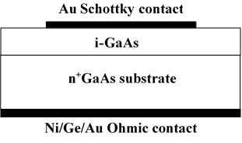
Fig. 1.1 Cross section of a Schottky diode used for capacitance-voltage measurement.
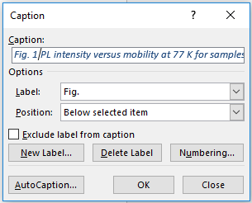
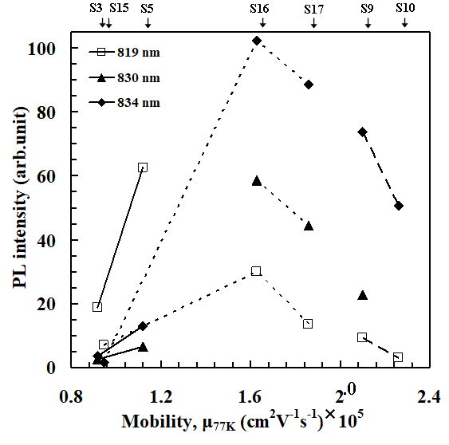
Fig. 2.1 PL intensity versus mobility at 77 K for samples from different lots at three different wavelengths. (Solid lines Lot A; thick broken lines Lot B; thin broken lines Lot D). Joined lines indicate the same lot.

